# De Silwa A.P.G.R.T - IT21806636

## Epic – Trainee Diary Online System

This function grants attention to the activity processes of a trainee. So this is important for those who train a lot. The Trainner begins by logging in to the system using their email and password. The validity is verified here. If a password is forgotten, it is possible to enter the system by renewing the password and using an item as a forgotten password. After that, the calendar page is shown. The projects, meetings, and tasks for each trainer in the relevant month are listed here. A small calendar is visible on one side. On the other hand, by clicking on 'create session', The Traineer is given the opportunity to enter the missed or missing data. When a trainner receives the 'create session' option. The form will be opened as 'create calendar items'. The option to enter data such as title, type, date-time, and message is available. Here, it is easy for the trainer to select task, meeting, or project by selecting the type from the drop down menu. The calendar representation includes these newly entered data as a project, meeting, or task once more. This entered data is stored in the database. Finally that the collected data goes to the HR division for the future use.

## Features, User Stories, Tasks, Estimation Method

### • Use Estimation Method as

|  |  |  |  |  |
| --- | --- | --- | --- | --- |
| **Features** | **User**  **Story ID** | **User Stories** | **Tasks** | **Estimation**  **Methods** |
| Login to the system |  | As a Trainee want to log into the system so that I can manage the Trainee information in the Trainee Diary Online System. | • Validate Email  and Password. | M |
| View at the Diary Page |  | As a Trainee I want to see all the relevant month projects, meetings and task details so that I can track all information. | * Trainee can view all the projects, meeting and tasks mentioned in the calender. * Implement a create session button. * Retrieves Trainee information from database. | M |

|  |  |  |  |  |
| --- | --- | --- | --- | --- |
| Create Calender item |  | As a Trainee I want to add new projects, meetings and task details to the system so that all the information can be easily accessed for the future needs. | * Create a form to enter projects, task, meetings details. * Implement a success message when new Trainneer details are successfully saved in the system. * Store the data in the database. * Added new details displayed on calender interface. | XL |

# Product Backlog

**Sequence diagram**

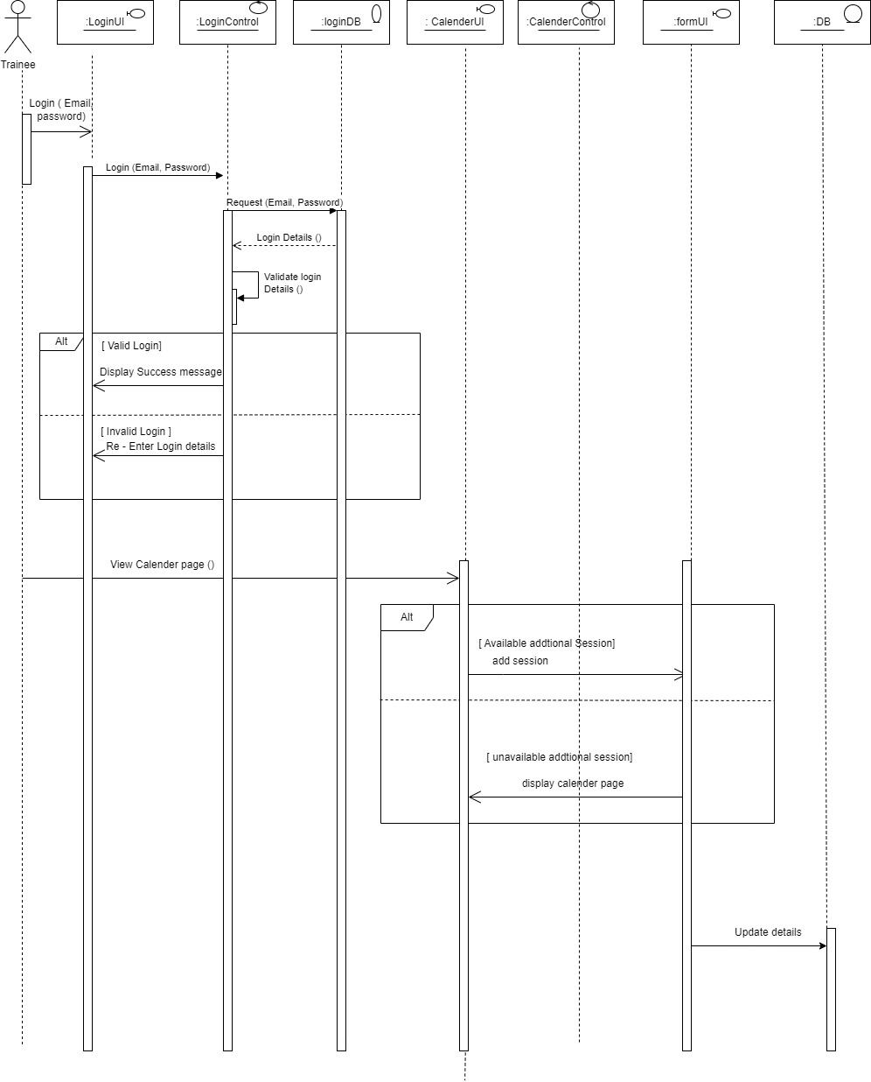

**Activity diagram**

